Camp Trico
Resident Camp Parent Information

Camp Trico Address: 315 Trico Drive, Guntersville, AL 35976
Amie Martin Camp Director’s cell phone: 205-730-6313

Arrive at Camp Trico between 5:00 pm and 6:00 pm Sunday
Depart Camp Trico at 3:00 pm on Friday
Thank you for registering for Resident Camp at Camp Trico. We are looking forward to an exciting summer! Please review the following information and keep it in a convenient place to help you prepare for camp and ensure your camper has the best experience possible.
Resident camp provides a unique experience that allows children to meet new friends, master new skills, and become more independent. Camp activities are designed to provide intentional opportunities to encounter new challenges, experience success, develop leadership, improve self-esteem, and build life skills. Spending a week at camp can build character and help children develop qualities that will serve them all their lives—strong values, social conscience and conviction about their own potential and self-worth.

Arrival at camp:
- Camper check-in will begin at 5:00 pm Sunday afternoon. Do not arrive before that time. Gates will open at 5:00 pm. There will be no camper access until the gates open as staff are busy preparing for camp and cannot supervise campers properly.
  - When you drive into camp through the front gate, you will drive straight down the drive until you see the parking lot in front of the dining hall on your right. The check-in at camp will be at the dining hall. The parking lot will be located on your right. Please park in the parking lot adjacent to the dining hall. Bring your camper’s labeled luggage with you to check-in. You will be directed to the appropriate cabin and will be able to drive to that cabin and unload luggage.
  - We recommend packing bedding separately if you would like to carry it to your child’s bunk to help make their bed.
  - Several stations will be set up in the dining hall to visit, including: General Check-in, Health Screen, Medication Drop-Off, Trading Post Account verification and Mail drop off.
  - All forms must be completed before dropping your child off. These include:
    - Camper Health Information (*including dietary restrictions)
    - Camper Code of Conduct
    - GSNCA Photo Release
Before summer camp:
- Talk to your camper about summer camp. Let them know what to expect. https://www.acacamps.org/resource-library/parents/preparing-children-summer-camp-experience
- Make sure all forms are completed and all questions are answered honestly. The questions are a tool for the summer camp staff to be best prepared for your camper. The information is confidential and is only shared with staff members who really need to know.

Where will campers sleep?
Most campers will sleep in air-conditioned bunk houses. Depending on the bunk house assigned, bathrooms are either inside the bunkhouse or a bath house is located nearby. Some campers will be assigned to non-air conditioned rustic cabins with a nearby bathhouse. The cabins have open air screened windows, and campers are welcome to bring a fan. In bunk houses, counselors sleep in the bunk house with campers. In a cabin, counselors are in a nearby cabin.
Cabin Mates:
Girls can request to be in the same cabin with another girl who is coming to camp at the same time and is close to the same age by completing the cabin mate portion of the registration form. Camp staff will do their best to accommodate requests. Please list only your top choice for cabin mate.
Food at Camp:
Food at camp is very important. The average camper walks 20,000 steps or more each day and is expending a great deal of energy doing camp activities. Meals are prepared in a commercial kitchen that is inspected by the local health department. The menu consists of popular food items that most campers enjoy. Breakfast, lunch and dinner will be served in the dining hall and snack will be served daily pool-side.
- Dietary accommodations can be made for camper’s needs, but only if they are included on the health form and submitted 2 weeks in advance of summer camp session. Please ensure you provide clear and specific information so we can best support your child’s needs.
Daily Schedule:
A typical day at camp may look like this:
8-9am | Breakfast
9am-12pm | Activity Rotations (for example: specialty activities, archery, waterfront, crafts, hiking, etc)
12-1pm | Lunch
1-3:30pm | Pool Time & Trading Post
3:30-6pm | Activity Rotations (for example: tubing, swimming in lake, team building, nature education, climbing wall, animal encounters, etc)
6-7pm | Dinner
7-9pm | All Camp Activities (for example: games and songs, campfire, skits)
Water Safety at Camp:
All campers will complete a swim test before participating in water activities at camp. The swim test will evaluate a swimmer’s ability to swim across the pool without stopping or touching the bottom and the ability to jump in water over their head, surface and tread water for 90 seconds. Swim tests will be conducted by certified Lifeguards. Based on evaluation, swimmers will be assigned to one of three categories:
- Guppy: Unable to complete either portion of the swim test. Must wear life jacket in pool at all times.
- Minnow: Passes swim across pool and back, but not able to pass the jump and tread water test. Restricted to shallow end of the pool unless wearing a life jacket.
- Shark: Passes both portions of the swim test. Able to swim in all areas of the pool without lifejacket required.
Girls who choose not to participate in the swim test will be assigned to Guppy level and must wear a lifejacket all times in the pool. Girls may arrange to retest with a lifeguard through the week if they would like to try a second time. Lifeguard decisions on swim ability are final. All campers are required to always wear lifejackets in open or moving water (lake or river). No exceptions.
Camp Appropriate Swimwear:
Swimwear for camp should be modest and functional. We understand that the definition of modest varies. For GSNCA, swimsuits must be one piece or modest tankini style that covers the mid-drift. Board shorts and short- or long-sleeve swim shirts are also acceptable.
Swimsuits can be any color, but if you are purchasing new swimwear for camp we ask you to consider the visibility of your swimwear before purchasing. The below graphic demonstrates underwater visibility for different colors of swimwear. Please avoid blues, teals or whites if at all possible to assist our lifeguards in keeping your campers safe.
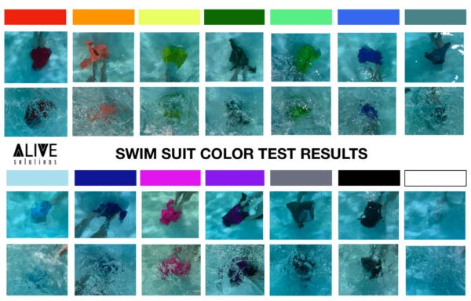

Packing for camp:
Packing for camp doesn’t have to be a challenge. Start early. When purchasing summer clothes, keep camp in mind. Things at camp will get dirty, they may get damaged, and unfortunately occasionally lost. Please keep this in mind and do not send anything to camp that you would be devastated if it returned ruined or did not return at all. Most importantly, LABEL EVERYTHING. You can use vinyl, sew on labels, tape or sharpie.
Packing List
Clothing (Packed in trunk or suitcase):
- 7 T-shirts
- 7 pairs of shorts
- 10 pair of underwear and bras for the week
- 10 pair of socks
- Tennis shoes
- Water shoes (Chaco/ Keen type- NO FLIP FLOPS)
- 2-3 modest bathing suits (one piece or tankini style swimwear – no bikinis)
- Rain jacket/ poncho
- Long sleeved shirt/ sweatshirt/ long pants
- pajamas
Shower/Bathroom (Packed in Shower Tote):
- Bath towel/ wash cloth/ body poof
- Swim/ beach towels
- Shower tote
- toiletries (shampoo, conditioner, body soap, toothbrush, toothpaste, deodorant, hairbrush, etc.)
- Flip Flops to wear in the shower
- Feminine Hygiene products (Please provide the camper with instructions on proper use and disposal.)
Bedding
- Twin sized sheets and blanket or sleeping bag (Mattress protector optional)
- Pillow/ camp friendly stuffed animal
General Camp Supplies
- Refillable water bottle that fully closes.
- Small backpack
- Hat/ sunglasses (optional)
- Stationary/ pens/ stamps (preaddressed envelopes are helpful)
- Dirty laundry bag
- Cards, book, puzzle games, etc.
- Flashlight (with new batteries)
- Sunscreen
- Insect repellant
Specialized Equipment:
- For Water Skiing – goggles, water shoes, water ear plugs, towel, optional extra one-piece swim suit
- For Sailing – water shoes,
Pack separately: medications (prescription, over the counter, topical, vitamins/ supplements)
Do not bring pets, alcohol, tobacco, e-cigarettes, firearms, fireworks, explosives.
Any Camper found to be in possession of these items will be sent home from camp. No refund will be given.

There is no need to lock trunks or bags at camp. GSNCA cannot be held responsible for lost keys or locks that must be destroyed because the key has been lost.
Packing Tips
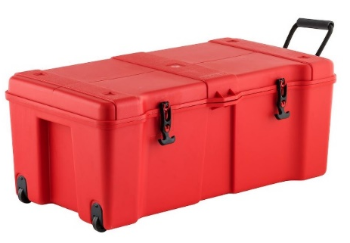
Your camper’s belongings will be stored on the floor, in the container that you pack in. Foot lockers seem to help keep everything in one place and allow your camper easy access while they are at camp. Campers can benefit by having outfits packed in zip lock bags for each day and extra clothes in additional bags. A list of what you pack is helpful in making sure that everything leaves camp with your camper. Make the list descriptive enough so the camper knows not only that they are missing a pair of shorts, but that they are missing a pair of red and black running shorts.

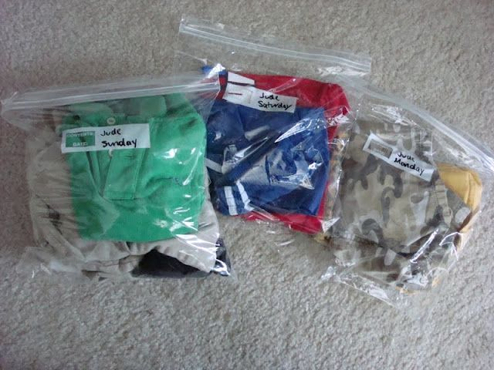

Technology at Camp:
We understand that in today’s world, everyone is connected through technology. Girls may bring their device with them, but will only be allowed to use it for short periods of time. The rest of the time, technology devices will be stored in a secure location. Wi-Fi is NOT AVAILABLE at Camp Trico. Staff will not monitor usage or determine what content is accessed by campers. For the safety of all campers, location services must be turned off. All devices, chargers and accessories should be well labeled. Girl Scouts of North-Central Alabama will not be responsible to damage to, loss, or theft of any electronic devices.
Camp Trading Post:
Campers can purchase camp souvenirs like T shirts, patches, craft supplies, and trinkets, as well as special treats like soda or ice cream throughout the week. *Please note sodas and candy will not be provided as snacks – they will be available for purchase only during trading post hours during pool time.* To aid you in planning Trading Post account amounts: candy and drinks will be $1 each, with some specialty drinks costing $2 each. Girls will purchase snack and drink tokens at the trading post to redeem for snacks and drinks at the pool.
Trading post merchandise prices range from $1- $25. The Camp Trading Post will be daily after lunch and during swim time for girls to make purchases. Parents can also pre-order items, or shop during check-in or check-out. Items that are preordered will be in the camper’s cabin when they arrive at camp. Additional money can be added to the trading post account through your UltraCamp account or at check-in.
Camp Staff:
Camp is led by an administrative team of year-round program staff, in cooperation with volunteer program directors. Summer camp seasonal staff consist of young adults. All staff must undergo an application and interview process complete with reference checks, background check and drug screening. All summer camp staff will be trained in first aid and CPR prior to the start of the camp season, as well as specific camp activities that they will be assigned to lead. Staff also participate in an intensive training period that includes sessions on child development, being a good mentor, recognizing and preventing bullying, conflict resolution, positive discipline, camp procedures, emergency procedures, leading activities, diversity and inclusion, and many other topics designed to ensure your camper has a positive, safe camp experience. The health care manager; the maintenance team; and the kitchen staff all work together to make sure operations run smoothly and help keep everyone safe.
Health Care at Camp:
All summer camp staff will be trained in first aid and CPR. In addition, a designated camp health manager is on duty to supervise routine healthcare, manage first aid, help campers manage medications, and, if necessary, activate local EMS. The first aid area is well stocked with common over-the-counter medications and health care essentials.
The health manager is a registered nurse or is currently certified in American Red Cross First Aid and CPR. Camp health manager has access by telephone to a network of health-care resources including GSNCA’s physician on-call. Arrangements are made with area hospitals and local emergency response personnel for complete services in case of emergency. Local Emergency Medical Services have been notified of the summer camp schedule and are familiar with the camp’s location and layout.
Medication:
Campers’ medications will be stored in a locked cabinet in the camp office except for emergency inhalers and epi pens. All medications must be in the original container. Medications will be dispensed as directed unless accompanied by instructions from the prescriber. Emergency inhalers and epi pens will be with the camper in the care of their counselor. Please label the actual inhaler/ epi pen if it is accidentally separated from the original box.
Please complete the medication form in your UltraCamp account and include it with your camper’s medication. Please note that the mobile health care center at camp is well stocked with common over the counter medication. There is no need to send Tylenol, bug bite medication etc. with your camper. If they need it, we have it on hand.
Sunscreen, Bug Spray and Ear Drops:
This year, all campers will have sunscreen and bug spray applied by camp staff as necessary to the daily activities. (Unless parents choose to opt out.) We use SPF 50 or greater sunscreen and OFF Family Care Bug Spray. Also, upon exiting the pool, each camper will get ear drops to help dry out ear canals and prevent ear infections. The ear drops are 50% Rubbing Alcohol and 50% vinegar. Parent can choose to opt out of this as well. At check-in, each family will be able to choose to participate in these preventative measures or opt out. If you have alternative products you wish to be used on your camper, please provide them.
Mail:
Campers love to receive mail. Be sure to write to your camper and encourage friends and relatives to do the same. Please keep letters cheerful and positive. We suggest sending mail at least a week in advance of the camp session, so that your camper will mail the first day. You can also drop mail at check-in. Please do not include food, drinks, or candy in mail packages as they are not allowed in bunk houses.
Please mail letters to: Camper’s Name
Camp Trico
315 Trico Drive
Guntersville, AL 35976

Campers enjoy writing home so be sure to send stationery and stamps. Prepare and send self-addressed envelopes or cards to make mailing easier.
Camp Rules:
- Absolutely no tobacco/e-cigarettes, alcoholic beverages, illegal drugs, fireworks, explosives, or pets are allowed at camp.
- Use the buddy system and use a flashlight at night. Do not leave the group/ area without notifying a counselor.
- Let counselors know if you need help.
- Wear the appropriate shoes and clothes to each activity. Campers who arrive at an activity not wearing the appropriate shoes or clothes will not be allowed to participate.
- Bullying, hazing, physical/ emotional torment, initiation practices, forced rituals and the like are strictly prohibited.
- Help keep camp clean! Pick up trash when you see it.
- Do not bring food, candy, or drinks into the cabins. The smell of these items attracts insects, animals, and worse. Chewing/ bubble gum is strictly prohibited at camp.
- Parents will be contacted to pick up any camper who exhibits behavior that is dangerous, disruptive, destructive, endangers other participants, or disrupts the program to such an extent that it negatively impacts the experience for other campers. If a camper is dismissed for these reasons, there will be no refund or reduction in camp fee.
- Parents will be required to reimburse Girl Scouts of North-Central Alabama for any damages caused by a participant to property including graffiti, torn, or cut screen, damaged beds, buildings, program equipment, etc.
When will we call you?
The summer camp staff will notify caregivers in the event of:
- Medical emergencies: In true emergencies, EMS will be called then the parent notified. Unless specifically requested otherwise, the child will be transported to the hospital via ambulance accompanied by a summer camp staff member.
- Non-emergent, serious, medical situations (potential broken bone/ cut requiring sutures): The camp staff will notify the caregiver who will have the option to pick the camper up from camp, meet camp staff at a medical facility, or request transportation via ambulance.
- Illness/ significant injury: The camp staff will notify you in the event of your camper being seen by the first aider for an injury requiring more than a band aid, or any illness with fever or vomiting. Any camper exhibiting symptoms of COVID-19 will be isolated and must be picked up from camp within 2 hours of first symptom. Camper will not be allowed to return to camp until a negative COVID test result is available.
- If the child is reported to exhibit abnormal behavior believed to be caused by a medical/ mental health condition.
- If the child violates a camp rule repeatedly or breaks multiple camp rules as described in the Camp Code of Conduct.
- If the child’s behavior is dangerous to themselves or disruptive to the general camp population.
- If the child is homesick to the point that the camp staff feel that parental consultation will be beneficial.
Pictures at Camp:
Staff will take pictures and videos of campers to be posted on the photo sharing page. Due to technology limitations, photos will not be posted until after campers leave. Access to the photo sharing page will be provided to caregivers via e-mail the week after their session ends. Campers may bring their own camera if desired, but please note cell phone cameras will be allowed during designated times.

Cancellations/ Refunds:
Registrations may be canceled at any time. The $50 deposit is non-refundable. The amount of the balance of the fees paid will be refunded based on when cancelation request is made. Requests made prior to 4 weeks before start of camp session will be refunded 100 % (Less deposit). Cancellations made 2-4 weeks prior to the start of camp session will be refunded 50% (Less deposit). Registrations made less than 2 weeks prior to the start of the camp session, are not guaranteed a refund. Refund requests for registrations cancelled less than 2 weeks prior to the start of the camp session or in the event of true emergency/ medical need will be determined by GSNCA CEO. All requests must made via email. Requests to cancel should be emailed to Kit at amartin@girlscoutsnca.org
Leaving Camp early or for an appointment:
If your child needs to leave camp for any reason, please let the camp director know as soon as possible. Come to the camp office to sign your child out and pick up all belongings that she will be taking with her. If a camper is planning to return, confirm return time with camp director during check-out.

Authorized Pick Up:
You must show your ID at pickup. Campers will only be allowed to leave camp property with the persons listed as “Authorized Pick- Up.” Parents should be listed as authorized pick-ups. If the authorized pick-up list needs to be changed while your camper is at camp, please notify the camp director via email. amartin@girlscoutsnca.org
Pick Up from Camp:
- Camp ends at 3:00pm on Friday. Campers will be busy with activities up until that point. All campers MUST be picked up no later than 5:00 pm.
- When you arrive at camp, drive to the check-out area at the dining hall to sign your camper out. Please have a photo ID available to verify that you are an authorized pick-up person.
- Pick up any medication from the first aider.
- You will be directed on where to meet your camper and collect their belongings.
- Remember to drive carefully out of camp as campers use the road as a sidewalk.

